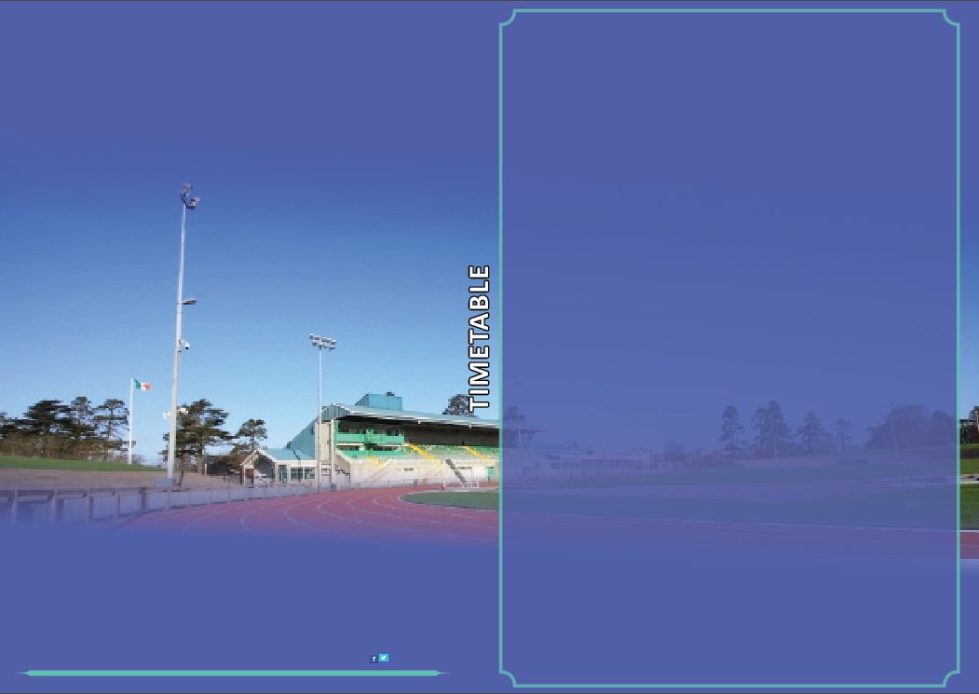

**Morton Live Athletics Open Meet**

28th August 5.30-9.00

Meeting Director-David Matthews

AAI Permit

**TIMETABLE**

**Under 16 5.30-6.45pm**

5.30-6.00pm U 16 100mts Boys & Girls

6.00pm U 16 800mtrs Boys & Girls

6.20pm U 16 3000mtrs Boys & Girls

**Senior Programme 7.00-9.00pm**

7.00pm 100mtrs Mens & Womens

7.45pm 800mtrs Mens & Womens

8.20pm 1 Mile Mens & Womens

[Davidmatthews@athleticsireland.ie](mailto:Davidmatthews@athleticsireland.ie)

0870516430