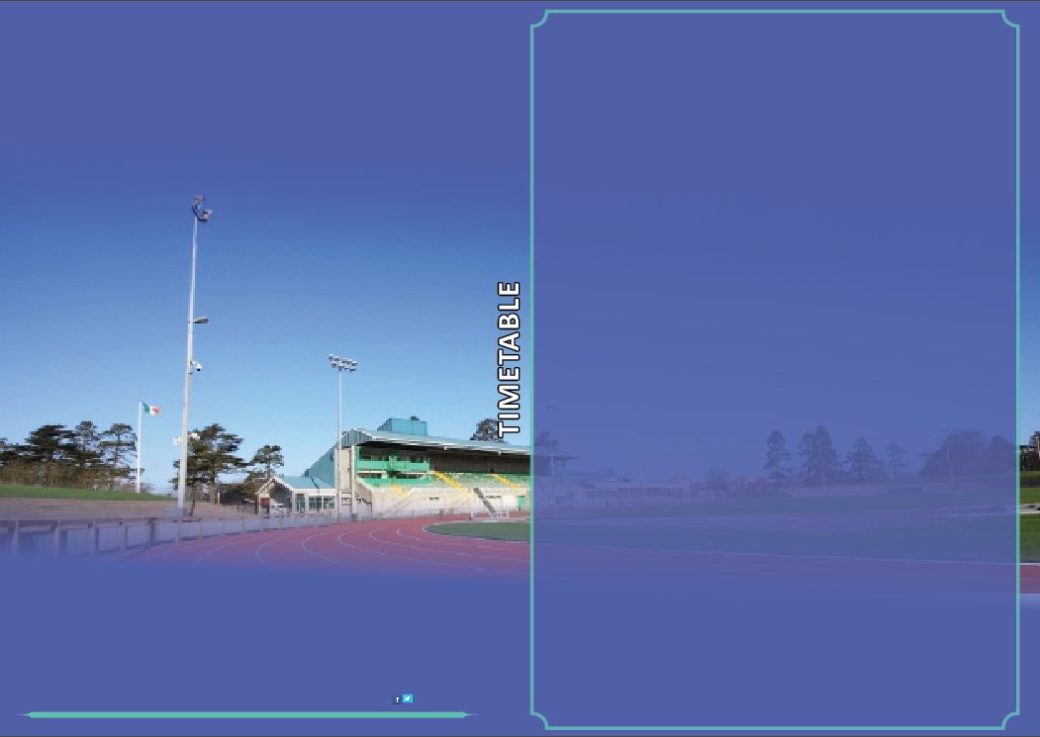

**Morton Live Athletics Open Meet**

4th September 5.30pm-9.00pm

Meeting Director-David Matthews

AAI Permit

**TIMETABLE**

**Under 12 Athletic Programme 5.15-6.30**

5.30-6.30 60mtrs /600mtrs Boys & Girls

**Under 14 Athletic Programme 6.30-7.45**

6.45-7.45 80mtrs / 800mtrs Boys and Girls

**Under 16 Athletic Programme 7.45-9.00**

8.00-9.00 100mtrs /800 mtrs Boys and Girls

[Davidmatthews@athleticsireland.ie](mailto:Davidmatthews@athleticsireland.ie)

0870516430