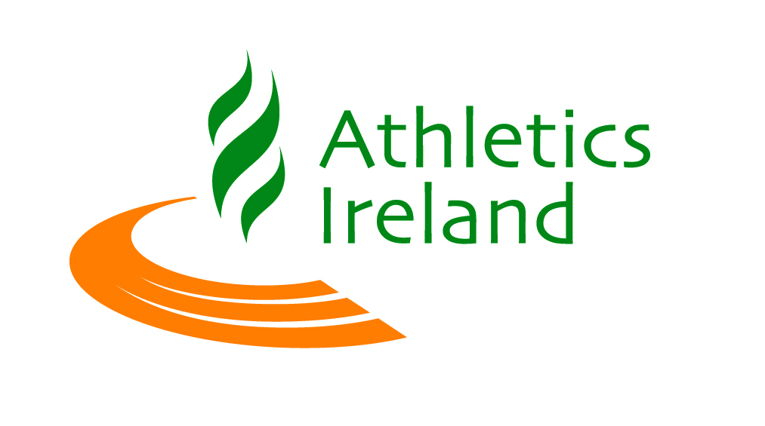

Team Declaration National 10k Championships 2016

Club ____________________________
Category

Male Female

Senior Master 35+ Master 50+

First Name | Last Name | Date of Birth | AAI Life Reg Number

Team Positions calculated on first 3 across line unless declared, finishing times, youngest age will apply to team category. All Clubs and County Teams must be pre entered either to declare the members of the team or to enter a team with no declaration.

Please return completed form to competition@athleticsireland.ie closing date for Team Declaration: Tuesday 5th April 2015, 5pm Sharp.

There is no fee for Team Entries set by Athletics Ireland

