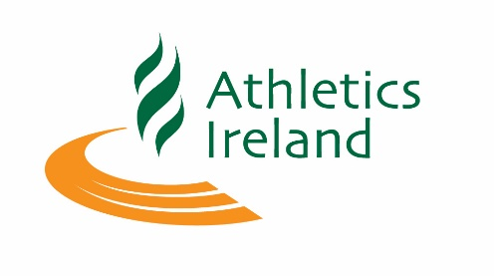

Team Declaration National 10k Championships 2019

Club :____________________________
Email: ____________________________
Phone: ____________________________

Category

Male Female

Senior Master 35+ Master 50+

First Name | Last Name | Date of Birth | AAI Life Reg Number

Team Positions calculated on finishing times of each athlete

Please return completed form to competition@athleticsireland.ie, closing date for Team Declaration 10th April 2019 2pm Sharp

There is no fee for Team Entries set by Athletics Ireland

