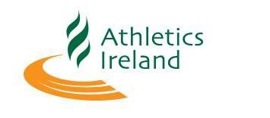
Team Declaration National Marathon 2019
Club _____________________________________________
Category

Male Female

Senior Master 35 + Master 50+
 | Name | DOB
1
2
3

Name:
Club Position:
Contact Number:
Email:

Team Declarations are to be submitted by 1pm Wednesday 23rd Oct 2019

